Chapter 5, Problem 19

Determine i_{o} in the circuit of Fig. 5.58.

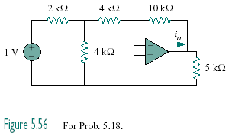
2 kΩ
750 mV

Figure 5.58
For Prob. 5.19.

